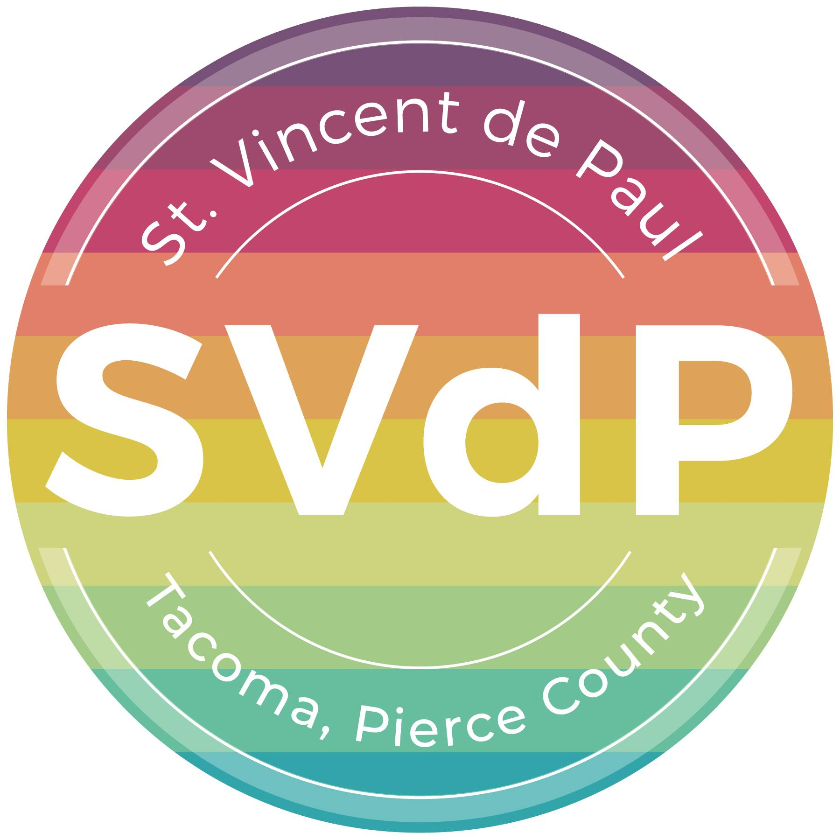
2026 Centennial Celebration:

St. Vincent de Paul of Tacoma, Pierce County’s
Annual Auction & Fundraiser

Friday, June 5, 2026 • Silver Cloud Point Ruston • Tacoma

Auction Item Donation Form

Donor/Business:
(as it should appear in the catalog)
Name:
Address
City: | State: | Zip:
Phone: | Email:

Donated Item Name:

(Please include all details such as quantity, size, color, number of persons, days/nights, expiration date, and restrictions, if any.)

Estimated Retail Value of Donated Item(s)
☐ Donor will provide actual item (if tangible) Delivery date: ____________
☒ Item must be picked up from donor Pick up date: __________
☐ Donor will provide a certificate (if a service or experience item)
☐ Please create a certificate with the information provided above
Donor Signature: | Date:
Donation Secured By: Gale Hemmann

DONORS: PLEASE MAKE A COPY OF THE COMPLETED FORM FOR YOUR RECORDS
St. Vincent de Paul of Tacoma, Pierce County | 4009 South 56th St, Tacoma, WA 98409 | 253-474-0519
Return no later than May 1, 2026 via mail or email to Kristen at kristen@svdptacoma.org
Tax ID: 91-0580490

